**Predicting Survival and Transplant Outcomes in PBC Patients Using Machine Learning Models**

1. **Introduction**

This project aims to classify the status of patients with Primary Biliary Cirrhosis(PBC) into 1 of 3 classes. The classes are: alive which will be referred to as ‘C’, alive and received a liver transplant which will be referred to as ‘CL’ and died which will be referred to as ‘D’. A synthetic dataset was created from a deep-learning model[1] to train some models. The deep-learning model was trained on data from a 1984 Mayo Clinic clinical trial[2]. The trial tested the therapeutic effectiveness of the drug ‘D-penicillamine’ on patients with PBC, a type of liver disease which gradually gets worse over time and the causes of which are unknown. This report will detail the trends observed in data exploration (Section 2), possible methods of imputation in cases of missing data (Section 3), treatment of unbalanced classes (Section 4), the range of models attempted and their results (Section 5) and our conclusions and recommendations (Section 6).

1. **Data exploration**

The synthetic dataset had the vitals of 13175 patients, 7905 were used as the training set and 5270 as the test set. The data available for each patient were: *ID, N_Days, Drug, Age, Sex, Ascites, Hepatomegaly, Spiders, Edema, Bilirubin, Cholesterol, Albumin, Copper, Alk_Phos, SGOT, Tryglicerides, Platelets, Prothrombin, Stage* and *Status*; descriptions of which can be found in (Appendix A).

For each numerical feature, we split the range of the data into equal bins. In each bin, we calculate the fraction of patients of each *Status* C, CL, and D and plot that fraction to observe any trends between the feature and the label *Status* as well as the values they occur at (an example can be seen in Figure 1b).

The trends observed in numerical features include:

* *Bilirubin* levels > 1.4 mg/dl indicate a higher likelihood of death
* *Cholesterol* levels > 200 mg/dl indicate a higher likelihood of death.
* *Albumin* levels > 3.2 gm/dl indicate a lower likelihood of death
* *Copper* levels > 90 ug/day indicate a higher likelihood of death
* *SGOT* levels > 130 U/ml indicate a higher likelihood of death
* *Platelets* levels > 140 indicate a lower likelihood of death
* *Prothrombin* values > 11s indicate a higher likelihood of death
* Patients in *Stage*s 1-3 have a higher likelihood of survival.
* *Patients in Stage 4 have the highest likelihood of obtaining a transplant: 4% compared to patients in Stage 3: 3.6%.*

The trends mentioned above can also be seen in the violin plots in Figure 2 where the median values, indicated by the bold line, for the different subsets of patients with *Status* C, CL and D all differ. This is especially noticeable for classes C and D.

In Figure 3, the distribution of the different classes in each categorical feature is shown. From this, we can see features *Sex, Ascites, Edema* and *Status* are very unbalanced and *Spiders* are slightly unbalanced. Because of this *Sex, Ascites, Edema* and *Spiders* might not be useful to include in the final model however due to *Status* being the label of our dataset, the feature we are trying to predict, we have to look at methods to remedy the balance. The remaining features *Drug* and *Hepatomegaly* are balanced. However, when performing a chi-squared test on the categorical features, *Drug* produces the lowest score at 5.88 and Hepatomegaly produces the highest at 1243.5. From this, we infer that the relationship between *Drug* and *Status* is not significant. This significance of a feature when predicting *Status* will be assessed by including all the features in the final model and assessing the features’ importance.

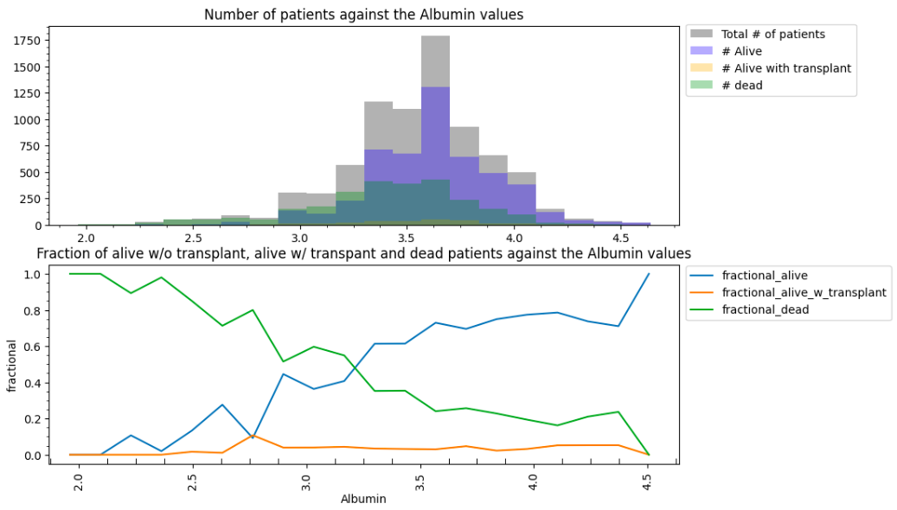

Figure 1: a) Histogram of *Albumin* values: for all patients in grey, for patients with *Status* C in blue, for patients with *Status* CL in yellow and for patients with *Status* D in green. b) Fraction of *Status* C, CL and D patients in each bin in blue, yellow and green respectively.

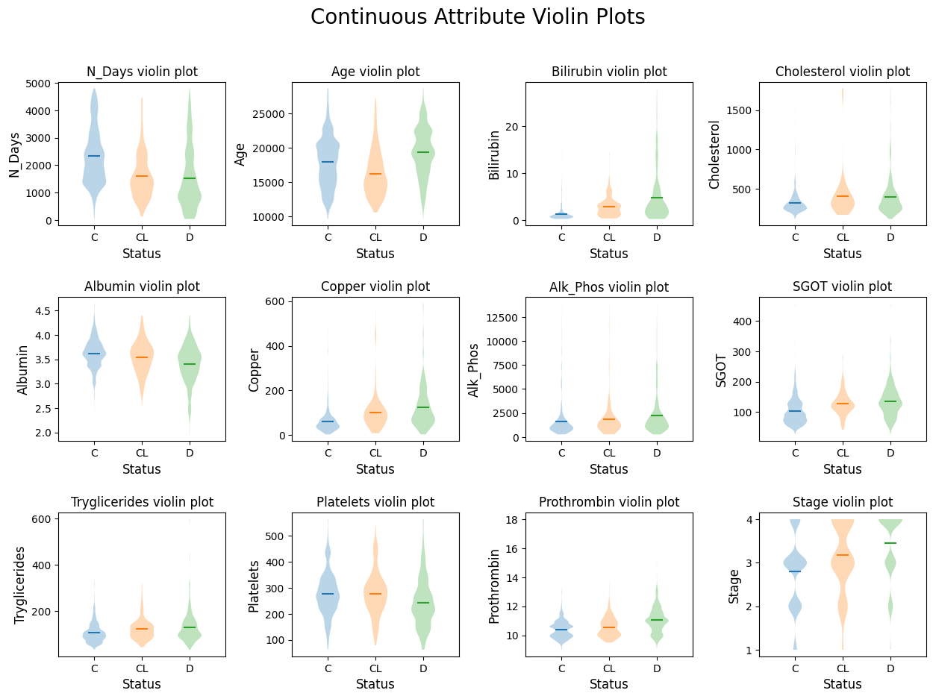

Figure 2: Violin Plots for the continuous attribute in the dataset

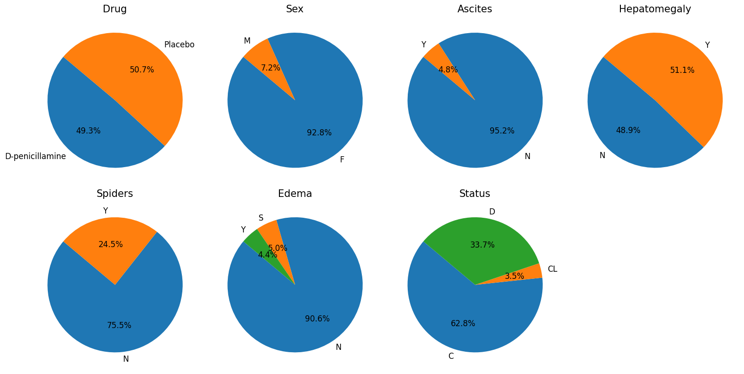

Figure 3: Pie chart of all categorical features in the dataset.

1. **Imputation methods**

In this report, 3 methods of imputation were tested: Simple Imputer, Iterative Imputer and KNN Imputer to compare with the original data and find which method performs the best at retrieving the original data.

We test 2 methods of Simple Imputation. For categorical data, both methods replaced the missing values with the most common value of that feature. For the numerical data, the first method used the mean value as a replacement and the second used the median value. The Iterative Imputer method works by modelling each feature as a function of all the other features making predictions using a regressor as to what the missing value might be. Finally, the KNN Imputer works by considering the nearest neighbours around the observation with a missing value and taking the average of the neighbour's values for that feature.

This dataset has no missing values so we first create a dataset with missing values by randomly removing a percentage of the dataset. Simple imputer and Iterative Imputer performed best at 5% of the data removed and KNN Imputer performed best at 10% of the data removed with 3 nearest neighbours. To compare the methods against each other, the imputed data from all the methods was then tested on a decision tree model with 2 parameters: criterion='log_loss', and min_samples_split=100, to ensure consistency. We found that the Iterative Imputer performed the best. Iterative Imputer and KNN Imputer both had similar accuracy however Iterative Imputer allowed for a better classification of the minority class ‘CL’ while the dataset from KNN imputer led to 0 predictions for the minority class seen in Figure 4.

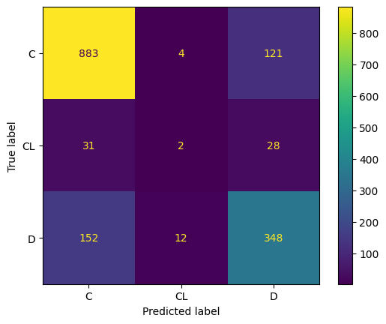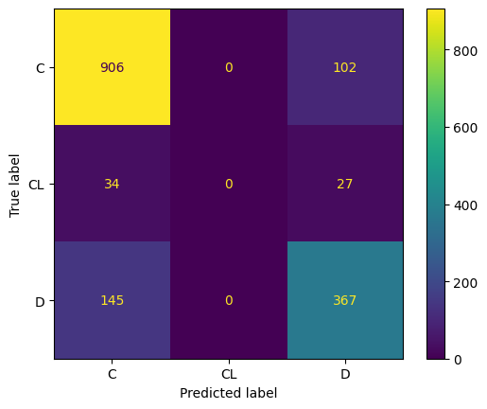

Figure 4: Confusion matrix for simple Decision Tree model using imputed data from an: Iterative Imputer(left) and KNN Imputer(right).

1. **Unbalanced classes**

The method of weight adjustment is to adjust the sample distribution during the training process by assigning different weights to samples of different categories. The classification report obtained in this project using this method shows a high accuracy (weighted average is 0.76). However, the recognition performance for minority class CL is poor, and its precision, recall and f1-score are all very low (0.33, 0.01 and 0.02 respectively), which indicates that the model has obvious difficulties in identifying minority class CL.

The SMOTE method increases the number of minority class samples by generating synthetic minority class samples, which can better simulate the distribution of the minority class. The classification report shows an accuracy comparable to weights (weighted average is 0.74), and in the recognition category CL There is also a certain degree of recognition ability (precision, recall and f1-score are 0.12, 0.41 and 0.19 respectively).

Therefore, although the weight-adjusted method is slightly better than SMOTE in terms of overall accuracy, SMOTE performs better when dealing with extremely imbalanced data sets.

1. **Assess models**

We attempted 6 models: Gaussian Naive Bayes, Random Forest classifier, Support Vector Machine classifier(SVC), Gradient boosting classifier, XGBoost and Logistic Regressor. The final parameters of each can be found in Appendix B.

SVC

SVCs work by coming up with a boundary between observations that try to split the classes up as accurately as possible. The SVC trained here uses a radial basis function(RBF) to decide these boundaries. RBF calculates the ‘similarity’ of 2 observations by considering their distances in feature space. The SVC model was trained on the oversampled SMOTE data and initially predicted most observations as Status ‘C’ with a Log-Loss score 5.996. Attempts at tuning the model reduced the score to 2.11 and increased the prediction of the class ‘D’ but it also reduced the correct classification of the minority class ‘CL’ by 50%.

GBC

We used the SMOTE method to oversample the training data when using this model. This model initially also classified most of the observations into state C, with a log loss of 0.519. We used a random search method to adjust the hyperparameters, and applied the best hyperparameters to the validation set for verification, which reduced the logarithmic loss to 0.518. Other metrics such as weighted average precision, recall, and F1 score also improved.

Random Forest Classifier

Another one of the models used to classify patients was a Random Forest classifier. Forest classifiers work by building many decision trees that each individually try to sort the data into a classification. The forest then classifies the individual into a group based on which classification was chosen the most by the decision trees generated. The forest classifier has multiple hyperparameters that were manually tuned to find the best performing model. The best performing forest classifier model had a log-loss of 0.506, an accuracy of 81% and a weighted average recall of 81%.

Logistic Regression Classifier

The logistic regression classifier is used to predict the outcome of patients. It looks at various features and learns how each factor affects the chances of each possible patient outcome. After the model is trained, it then estimates these probabilities for patients in testset. This model achieved a correct prediction rate of 65%, meaning it accurately predicted the patient's outcome 65 times out of 100. It was best at forecasting the unfortunate event of patient deaths and less precise for the survival and transplant scenarios. The log loss value is 0.81.

Gaussian Naive Bayes

Considering our data involves predicting certain disease conditions in the medical field, the Gaussian Naive Bayes model was attempted as it requires the data features to be continuous variables, assuming they follow a Gaussian distribution. During the training on the feature set, it can be observed that the model performs relatively well on the "survival" category, with a recall of 0.91 and precision of 0.75. However, for the "death" category, the recall is lower at 0.44, though the precision is higher at 0.81. In contrast, the "post-treatment survival" category shows poor performance with a recall of 0.08 and precision of 0.05. The model's MSE is 0.86, and the log loss is 2.59, which are high indicators, suggesting that this model is not very suitable for our data. The possible reason might be that one of the premises of Gaussian Naive Bayes is the need for data features to conform to a Gaussian normal distribution, but some features in our data do not meet this precondition. Moreover, in our data, it cannot be ensured that each feature is independent of one another, which could also affect the accuracy of the Gaussian model. Therefore, this classifier is only attempted and not selected as the best model.

XGBoost

Regarding the XGBoost model, in addition to similarities with other models, such as good accuracy, recall rates, and F1 scores for the "survival" and "death" categories, the XGBoost model has a higher recall rate for the "CL" category compared to the Gaussian Naive Bayes, with an accuracy of 0.5. The F1 score results indicate that the model also performs well in balancing recall and accuracy. With an MSE score of 0.59, which is lower than that of Gaussian Naive Bayes, it demonstrates a better ability to reduce prediction errors, lowering the deviation in predicting certain categories. Furthermore, the Log Loss is 0.53, showing that the model has a closer approximation between predicted probabilities and actual probabilities. For this model, we have utilised hyperparameter tuning and cross-validation to find the optimal model configuration, resulting in a log loss score of 0.50.



Figure 4: Final Kaggle score on the test set

1. **Recommendations**

As mentioned earlier, the initial dataset originates from a clinical trial testing the effectiveness of D-penicillamine. By considering the initial data exploration, specifically the Chi-squared value of *Drug* we can see that the feature *Drug* has little correlation with a patient’s *Status.* Furthermore, by considering the feature importance values seen in Figure 5, we conclude again that *Drug* has little importance in classifying a patient’s *Status*. From this, we can infer that D-penicillamine is ineffective in helping treat PBC similar to the initial paper for the clinical trial[3] as well as a subsequent trial by Gong. Y et al[4].

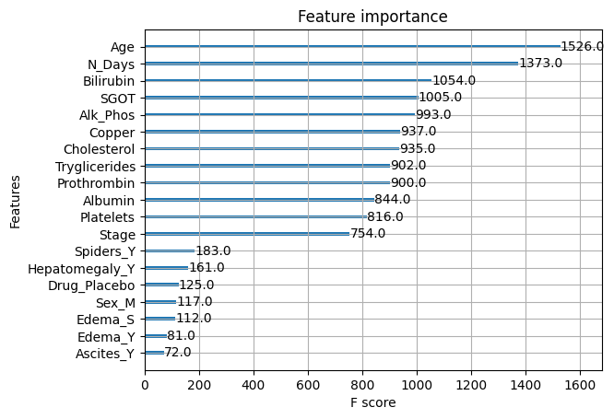

Figure 5: Feature Importance of the final XGB model.

1. **Conclusion**

In summary, our study emphasises comprehensive data exploration, effective imputation techniques, and appropriate methods to balance the data and select appropriate models to predict the results on the test set. In particular, the XGBoost model showed good performance in classifying PBC patient status, with the lowest logloss of 0.501 among all selected models. Compared to the baseline estimator, which predicts the patient is in Status C for every observation and thus has an accuracy of 63%, our model is more accurate with an accuracy of 80% and therefore we believe it can reasonably predict the status of a patient with PBC. A limitation of the models is the use of N days. As seen in Figure 4 it is the 2nd most important feature in our model and as such heavily impacts the predictions. However, it limits the future use cases of the model as this data is not available for patients who are newly admitted. Because of this, we recommend our model be used for patients who have already been admitted for several days. The patient’s doctor can then check the resulting prediction of the patient’s Status before deciding on a course of action.

**Appendix A**

| **Feature** | **Description** | **Values** |
| --- | --- | --- |
| ID | Unique Patient Identifier | 0 to 13174 |
| N_Days | Number of days from the patient initially joining the study to the first of death, obtaining a transplant or end of the study | Integer values between (41, 4795) |
| Drug | Was the patient given D-penicillamine or a placebo | ‘D-penicillamine’ or ‘Placebo’ |
| Age | Patient’s age in days | Integer values between(9598, 28650) |
| Sex | Patient’s Sex | ‘M’ or ‘F’ |
| Ascites | Accumulation of excess fluid in the abdomen | ‘Y’ or ‘N’ |
| Hepatomegaly | Enlargement of the liver more than normal | ‘Y’ or ‘N’ |
| Spiders | Dilation of blood vessels found under the skin | ‘Y’ or ‘N’ |
| Edema | Swelling caused by fluid collection in tissue | ‘Y’ if present and not solved by diuretic therapy, ‘S’ if present and no diuretic therapy or if solved by diuretic therapy, ‘N’ if not present |
| Bilirubin | The compound created during the breakdown of aged or abnormal red blood cells | Continuous value [mg/dl] |
| Cholesterol | A type of lipid found in the blood | Continuous integer value [mg/dl] |
| Albumin | A family of proteins made by the liver | Continuous value [gm/dl] |
| Copper | Metal carried by a protein called ceruloplasmin | Continuous integer value [ug/day] |
| Alk_Phos | Alkaline phosphatase, an enzyme | Continuous value [U/liter] |
| SGOT | An enzyme, serves as a marker for liver function | Continuous value [U/ml] |
| Tryglicerides | A type of lipid found in the blood, serves different purposes from cholesterol | Continuous integer value |
| Platelets | Cells that bind together to form clots | Continuous integer value [x10-3/mm3] |
| Prothrombin | A type of protein created in the liver that acts as a clotting factor. What is actually measured here is the prothrombin time which is how long it takes for a clot to form in a blood sample | Continuous value [s] |
| Stage | Severity of liver disease | 1, 2, 3 or 4 where 1 is least severe |
| Status | Whether the patient is alive, dead or got a liver transplant by the end of N_days. | ‘C’: alive, ‘CL’: alive and received a transplant or ‘D’: dead |

Appendix

| **Model** | **Best LogLoss Score** | **Parameters Used** |
| --- | --- | --- |
| XGBoost | 0.5006611077616914 | objective='multi:softprob',num_class= 3, eval_metric='mlogloss',learning_rate=0.1,max_depth=6,subsample=0.8,colsample_bytree=0.8,random_state=42 |
| Random Forest Classifier | 0.505938176971948  2 | criterion="log_loss", min_samples_split=5, max_depth=30, min_samples_leaf=2, n_estimators=200 |
| Gradient Boosting | 0.5184596433721362 | learning_rate=0.1, max_depth=8, min_samples_leaf=12, min_samples_split=9, n_estimator=120 |
| Gaussian NB | 0.703287652484924 | var_smoothing= 1.0 |
| Logistic Regression | 0.8091920930875935 | multi_class='multinomial', max_iter=1000 |
| SVM | 2.1199206070965544 | C= 8, gamma= 0.5, kernel= 'rbf' |

1. Walter Reade, Ashley Chow. (2023). Multi-Class Prediction of Cirrhosis Outcomes. Kaggle. https://kaggle.com/competitions/playground-series-s3e26
2. Dickson, E. R., Fleming, T. R., Wiesner, R. H., Baldus, W. P., Fleming, C. R., Ludwig, J., & McCall, J. T. (1985). Trial of penicillamine in advanced primary biliary cirrhosis. *New England Journal of Medicine*, *312*(16), 1011–1015. https://doi.org/10.1056/nejm198504183121602
3. Dickson, E. R., Fleming, T. R., Wiesner, R. H., Baldus, W. P., Fleming, C. R., Ludwig, J., & McCall, J. T. (n. 2)
4. Gong, Y., Frederiksen, S., & Gluud, C. (2004). D-penicillamine for primary biliary cirrhosis. *Cochrane Database of Systematic Reviews*. doi:10.1002/14651858.cd004789